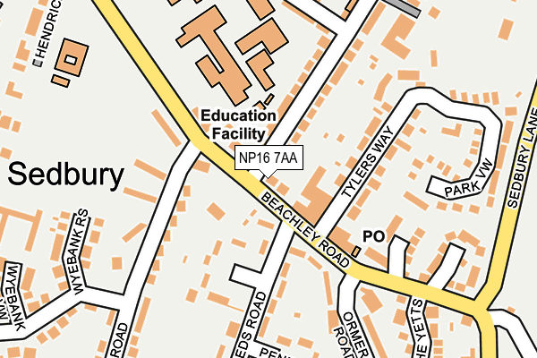
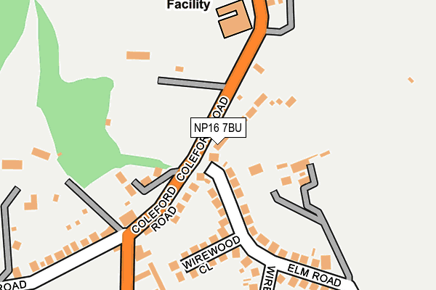
Tanya’s
Local Roads
Puzzle

Welcome to our next Wordsearch Puzzle.

The last Puzzle was finding MAMMALS from within the UK. This time you are looking for some of the ROADS that may be found within our Parish.

There are 29 LOCAL ROADS to locate here.

See what you can find and then spell out the remaining letters in order to give four more LOCAL ROADS as the puzzle answer
tanya.rockymead@gmail.com

ARLINGTON | GLOUCESTER | ORMEROD
BEACHLEY | GRAHAMSTOWN | PARK
BIGSTONE | HENDRICK | PENDA
BUTTINGTON | KING ALFREDS | SAXON
CASTLE | LOOP | SEDBURY
COLEFORD | MADOCKE | SILLEYS
DANES | MARTINS | WIREWOOD
DENMARK | MERCIAN | WYEBANK
EDMOND | MOPLA | YETTS
ELM | OFFAS
G | L | O | U | C | E | S | T | E | R | T | Y | Y | S
L | R | S | Y | E | L | H | C | A | E | B | R | N | P
N | E | A | D | N | E | P | S | D | I | U | I | S | A
A | E | F | H | R | S | A | E | G | B | T | S | I | R
I | D | F | L | A | X | N | S | D | R | T | W | L | K
C | M | O | E | O | M | T | E | A | E | I | Y | L | N
R | O | V | N | A | O | S | M | L | R | N | E | E | O
E | N | L | R | N | S | P | T | E | E | G | B | Y | T
M | D | K | E | T | R | S | W | O | N | T | A | S | G
O | N | O | T | F | A | O | R | S | W | O | N | E | N
P | E | E | K | C | O | D | A | M | B | N | K | N | I
L | Y | L | R | D | O | R | E | M | R | O | I | A | L
A | D | M | G | H | E | N | D | R | I | C | K | D | R
K | I | N | G | A | L | F | R | E | D | S | E | T | A

- Our roads may include a variety of names: WYEBANK may include ROAD, CRESCENT, VIEW, WAY or RISE…
- A CLOSE may be WIREWOOD, OFFAS, SILLEYS or BIGSTONE
- There is a MERCIAN WAY and a DENMARK DRIVE to be found
- Also there are several different PLACE like PENDA or SAXON
- Hope that you can find your WAY around these familiar places
- Here is the answer of a previous Wordsearch puzzle:
- FAVOURITE CHOCOLATE BRANDS PUZZLE: CURLYWURLY PICNIC and AFTEREIGHT (9 May)

